Jonesboro United Methodist Preschool Program
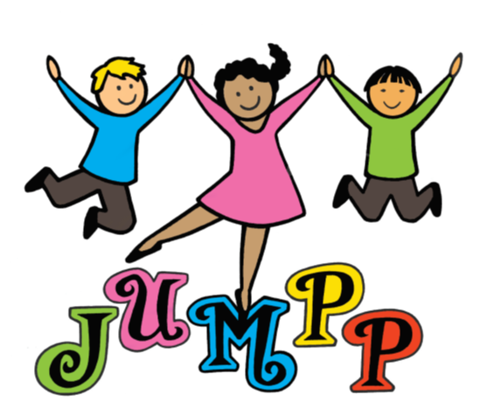
Welcome
Jonesboro First United Methodist Church would like to take this opportunity to welcome your family to Jonesboro United Methodist Preschool Program. Our school is one of our many ministries within the church and provides a variety of opportunities for children to grow and mature in a Christian based environment while achieving academic success.

Our mission is to seek and honor God by offering a Christ-centered foundation for the spiritual, academic, physical, and social growth of children to prepare them for future educational endeavors.

We believe parent participation at home and in school is essential to the success of your child’s progress. The school offers many opportunities for parents to be engaged in our school and experience your child's day-by-day environment at JUMPP. We encourage you to take advantage of these opportunities.

Communication between the school, teachers, and home is extremely important in your child’s educational success. Therefore, newsletters and calendars from the teachers, as well as weekly email notifications from JUMPP’s office is an efficient way to keep you informed of all the school activities. Our website www.jonesboroumc.com/preschool also provides general information about the school.

At JUMPP, we are committed to all our students and their families to prepare them for a solid start for their future. We at JUMPP are extremely excited about the new school year and are delighted to work with you during this and other school years to come.

For the children,

Director

